CSA1503-Cloud computing and big data analytics
Experiment-6
Create a simple cloud software application for Payroll Processing System using any Cloud Service Provider to demonstrate SaaS include the necessary fields such as Name of the employee, experience in present org, over all experience, basic pay, HRA, DA, TA, net pay, gross pay etc.
INPUT
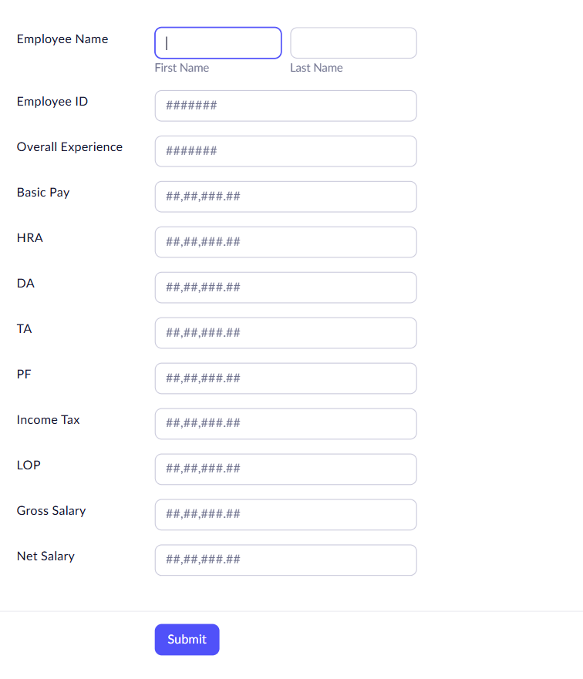
OUTPUT
